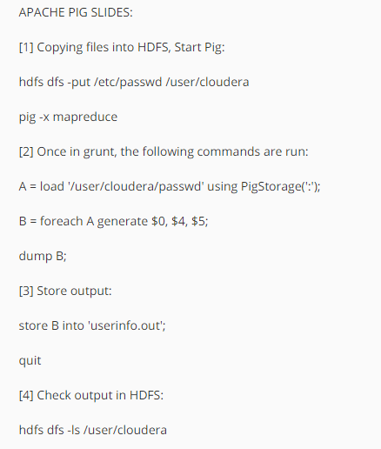

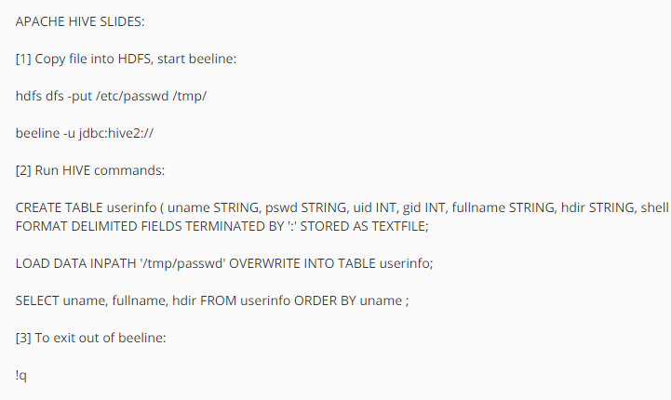

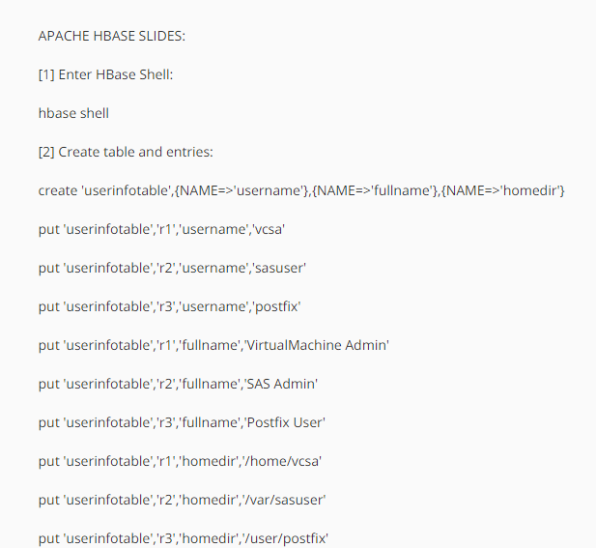

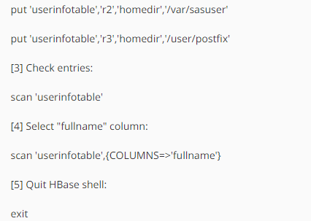

Following are references for some of the material covered:

Pig Documentation:

<http://pig.apache.org/docs/r0.15.0/start.html>

Pig Latin basics:

<http://pig.apache.org/docs/r0.15.0/basic.html>

HIVE Language Manual:

<https://cwiki.apache.org/confluence/display/Hive/LanguageManual>

HBase Reference Guide:

<http://hbase.apache.org/book.html#arch.overview>